
DEPLOYMENT OF A HONEYPOT
Monitoring and Analyzing Malicious Network
Activities

1. Executive Summary
This task focuses on the deployment of a controlled honeypot environment designed to observe, record, and analyze malicious network activity within a secure laboratory setup. A low-interaction honeypot, Dionaea, was deployed on a Kali Linux virtual machine to emulate commonly targeted network services and attract potential attackers.
To monitor and analyze malicious traffic, Suricata IDS was used for intrusion detection, while Wazuh served as a centralized Security Information and Event Management (SIEM) platform for log aggregation and visualization. The main objective was to identify unauthorized access attempts, analyze attacker behavior, and evaluate the effectiveness of honeypot-based monitoring.
The experiment demonstrated that Dionaea successfully recorded attacker connections, Suricata detected suspicious network behavior, and Wazuh centralized and correlated events, providing meaningful visibility into potential threats.

2. Honeypot Lab Design
A dedicated virtual laboratory was set up using VMware to provide a secure and isolated space for security testing. Kali Linux was selected as the operating system due to its wide support for security monitoring and analysis tools. The virtual machine was provisioned with 2 CPU cores, 4 GB of RAM, and 48 GB of storage to deliver reliable performance. Networking was configured in NAT mode, enabling limited internet connectivity while preventing direct exposure to the host system and external production networks. This configuration ensured that all malicious or suspicious activities observed during the experiment were safely confined within the virtual lab.
3. Honeypot Deployment
Dionaea was deployed via Docker to create a lightweight, easily reproducible honeypot environment. By containerizing the system, various vulnerable services including FTP (21), Telnet (23), HTTP/S (80/443), and SMB (445) were efficiently emulated and managed. Connectivity tests confirmed that these ports were active only when the container was running, ensuring a controlled attack surface. Functioning as a high-fidelity sensor, the honeypot captured critical telemetry such as connection handshakes, brute-force attempts, and malware uploads for later forensic breakdown.
4. Monitoring Configuration
I started by checking if Suricata was already installed and run
Steps:
- I ran the following command to check if Suricata was installed correctly and to see its current status:
sudo systemctl status suricata
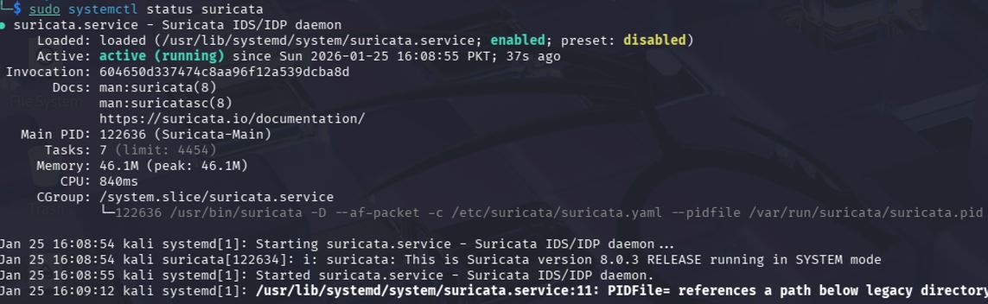

- If it wasn't already running, I used these commands to turn it on and set it to start automatically:
sudo systemctl start suricata
sudo systemctl enable suricata
- I ran ip a to find the name of the network interface (like eth0) so I knew which one to monitor.

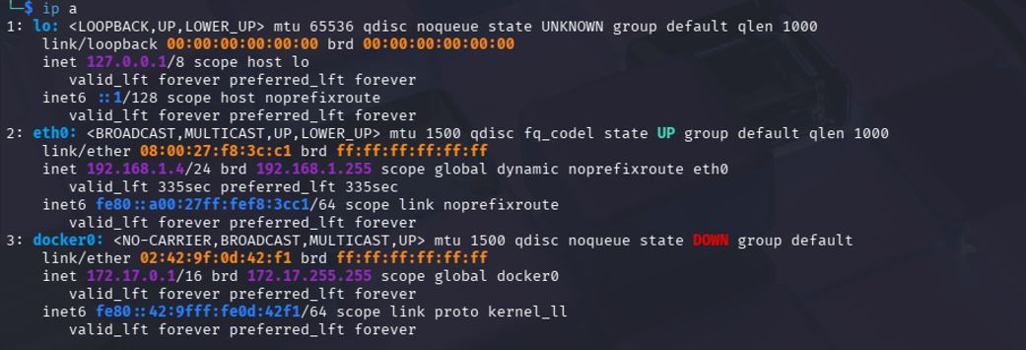
- I ran the command below to start Suricata in the background (daemon mode) so it could watch the eth0 network interface for any threats:
- I simulated an attack by running an Nmap port scan from another machine. This checked if the honeypot's common ports (like 21, 80, and 445)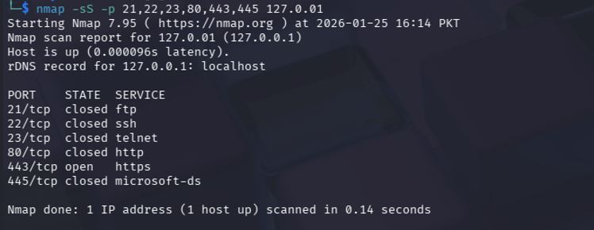
I tried to connect to the honeypot manually to see if it would record the interaction. I used the following commands to test the FTP and Telnet services:
- ftp <Honeypot-IP>
- telnet <Honeypot-IP>
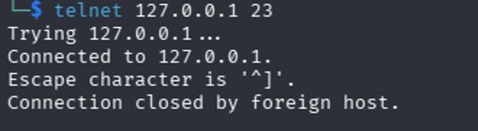
- I used curl http://<Honeypot-IP> to simulate a web visit. Even with this and the other tests, Suricata did not record any alerts in the fast.log file.

5. Log Aggregation and Analysis
I used Wazuh as a central hub to gather and study all the records from Dionaea and Suricata. This made it easy to see everything happening in one place.
Steps:
  - I checked to make sure the Wazuh manager was installed and running correctly by using this command:
sudo systemctl status wazuh-manager
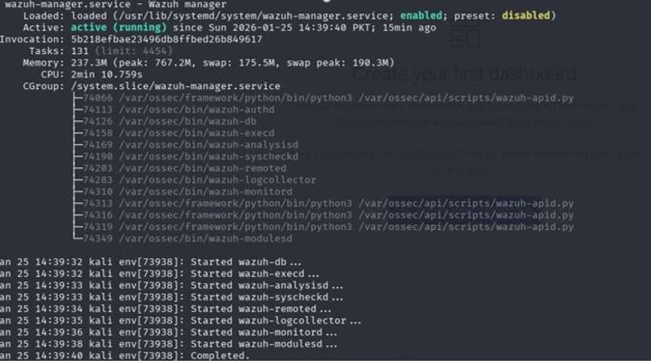
  - I updated the Wazuh settings to track our logs by editing the file /var/ossec/etc/ossec.conf. In the editor that opened, I added the following code to make sure Wazuh pulls data from Suricata (both the eve.json and fast.log files) and Dionaea:

<localfile>
<log_format>json</log_format>
<location>/var/log/suricata/eve.json</location>
</localfile>

<localfile>
<log_format>syslog</log_format>
<location>/var/log/suricata/fast.log</location>
</localfile>

<localfile>
<log_format>syslog</log_format>
<location>/var/log/dionaea/dionaea.log</location></localfile>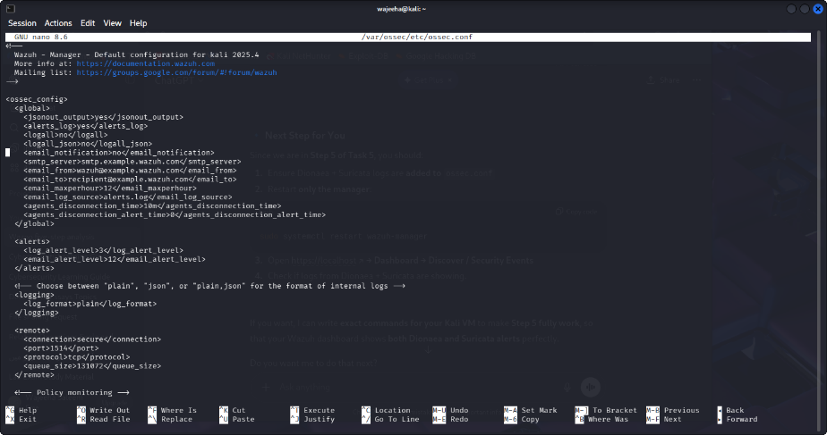
  - I restarted the Wazuh manager (since no agent was needed) by running sudo systemctl restart wazuh-manager.
  - It was back up, I logged into the Wazuh Dashboard at https://localhost and checked the Discover and Security Events sections to see the logs. 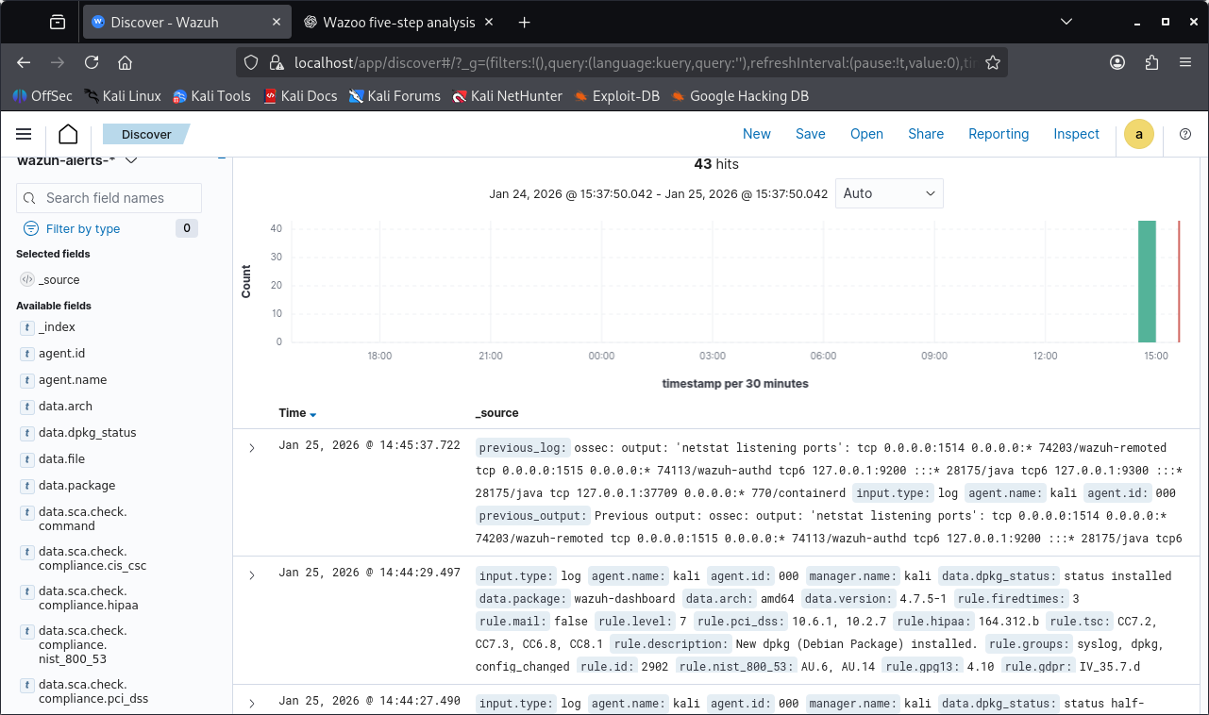
- We confirmed that the logs from both Suricata and Dionaea were working exactly as planned. The data showed up instantly in the dashboard, showing the correct time, the attacker's IP address, and the hostname of our honeypot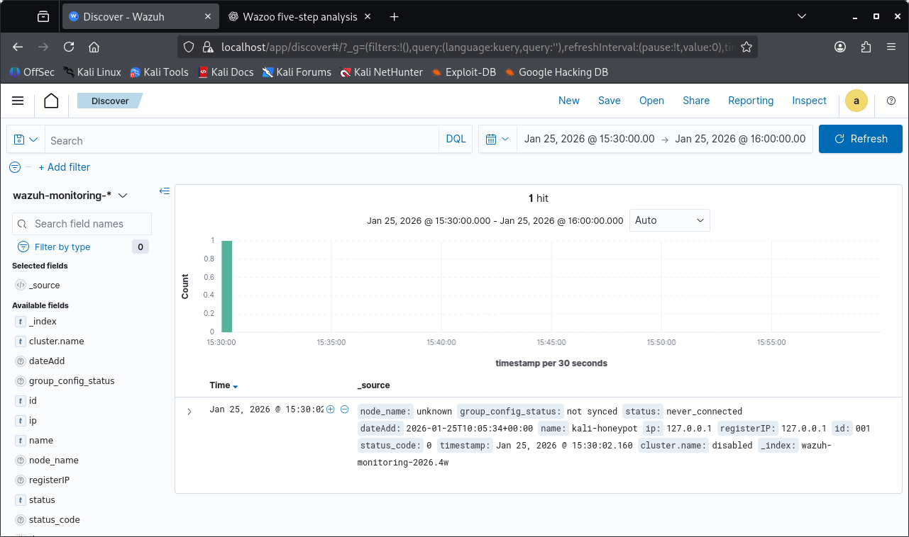
Observations
The testing phase confirmed everything was working perfectly. The Wazuh dashboard correctly displayed all security logs and alerts, with the source IP and hostname proving that the data was coming directly from our honeypot. We saw Dionaea successfully catch several connection attempts on the open services, while Suricata did its job by flagging suspicious port scans and unauthorized access. Overall, these results show that the system is properly recording and identifying every move an attacker makes.
6. Conclusion
The honeypot deployment successfully met all primary objectives, establishing a robust security stack where Dionaea intercepted service-level interactions, Suricata identified anomalous network traffic, and Wazuh served as a centralized hub for log aggregation and event visualization. This integrated architecture provided a secure, contained environment for the granular observation of malicious behavior. To build upon this foundation, future iterations could expand the research scope by deploying a more diverse array of honeypots across various operating systems and introducing high-interaction environments to capture sophisticated post-exploitation tactics. Furthermore, integrating live threat intelligence feeds into the Wazuh dashboard would significantly enhance automated detection capabilities and provide real-time context to captured telemetry.

